**Software Engineering Project**

**Winter 2021**

**Clinic Reservation System**

**Team members** (*filled by PM, Team Leader*)**:**

| **N**  **o** | **Name** | **Surname** | **Student ID Role** |
| --- | --- | --- | --- |
| 1 | Kaan | Koşti | 252548 |
| 2 | Andrii | Tymofieiev | 257291 |
| 3 | Mahammad | Hashimov | 257310 |
| 4 | Chima | Nwokeocha | 257272 |
| 5 | Alimuzzaman | Bhuiyan | 254736 |

**Team members activity** (*filled by PM, Team Leader after each class*)**:**

| **Date** | **4 Oct** | **11**  **Oct** | **18**  **Oct** | **25**  **Oct** | **8 Nov** | **22**  **Nov** | **29**  **Nov** | **6**  **Dec** | **13**  **Dec** | **15**  **Dec** | **3**  **Jan** | **10**  **Jan** | **17**  **Jan** |
| --- | --- | --- | --- | --- | --- | --- | --- | --- | --- | --- | --- | --- | --- |
| **Members** | **1** | **2** | **3** | **4** | **5** | **6** | **7** | **8** | **9** | **10** | **11** | **12** | **13** |
| **1** | **S** | **S** | **S** | **S** | **S** | **S** | **O** | **S** |  |  |  |  |  |
| **2** | **S** | **S** | **S** | **S** | **S** | **S** | **O** | **S** |  |  |  |  |  |
| **3** | **S** | **S** | **O** | **S** | **S** | **S** | **S** | **S** |  |  |  |  |  |
| **4** | **S** | **S** | **S** | **S** | **S** | **S** | **S** | **S** |  |  |  |  |  |
| **5** | **S** | **S** | **O** | **S** | **S** | **S** | **S** | **S** |  |  |  |  |  |

*Activity symbols:*

| **Symbol** | **Description** |
| --- | --- |
| **-** | *Absent* |
| **S** | *Standard* |
| **O** | *Outstanding* |

1

**Software Engineering** Project

**Winter 2020**

**1. Elaboration of application concept (F1)**

1.1. Aim of the Project

*This section presents a short description defining the aim of the project. It should*

*reflect projects’ objectives agreed with the teacher.*

Recently, the increase in the number of hospitals in many countries is an obvious trend, mainly due to the need to provide medical services to more and more patients due to various forms of diseases, a scenario that is led by the management of the hospital to provide appropriate services. Booking medical appointments is one of the most important tasks in ensuring efficient healthcare.The aim of our project is to have a friendly interface that allows the user to book an appointment when needed and have the necessary needs to be delivered to their home without effort.

Addition to the given idea we also can have an online web tool that allows patients from all over the world to get the needed medicine to be verified from the source and delivered to them to their home directly.

Features:

- easy and fast reservation from home

- a translator that allows the patient to see a foreign doctor

- possibility of various doctors for different illnesses

- possibility of buying medical drugs via web

1.2.General Assumptions

*This section describes the idea of the project. It should focus on the vision of artefacts*

*and part of reality being a context for business analysis.*

The idea of our project is to allow users to create accounts. There will be 2 types of authorized users one is for patients and the other one is for doctors. Users will be able to make appointments for more than one doctor. They can

also get an appointment for common medical tests(covid-19,blood test, HIV). Users can check their test results and send directly to the doctor for examination. The user has the right to also choose his own doctor and check his work experience and rating. Users can contact the doctor via online consultation service if needed.

Doctors can check the appointment date , information about patients and test results from the laboratory. And if the doctor cannot attend the appointment he can refer to another available doctor.

Translator allows the patient to talk or have a meeting with a foreign doctor without any problems. All the available data will be available in the desired language upon request.

We have a developer team whose sole purpose is to build the platform and provide technical help or knowledge as well as handling the website.

There is also another feature for users to get medical needs from an online drugstore with verification from the doctor. Users can also check for availability of medicines in the database. They will be provided with the substitute drug if there is no available mentioned drug from prescription.

2

**Software Engineering** Project

**Winter 2021**

1.3. Stakeholders Description

*Define the stakeholders of the project and put them on the table, along with their roles.*

*The table should also contain assignments to projects’ parts that reflect the responsibilities*

*of a given stakeholders group.*

| **Stakeholders** | **Roles** |
| --- | --- |
| Patient | A person who is receiving medical treatment from a doctor or hospital. A patient is also someone who is registered with a particular doctor. |
| Doctors | A person with a medical degree whose job is to treat people who are ill or hurt. Also, they can write prescriptions if medical attention is needed. |
| Suppliers | A person, company, or organization that sells or supplies something such as goods or equipment to customers. They also manage transportation for supplies |
| Call Support | Medical students as well as doctors & their assistants can be of help if a patient does not know what kind of |

|  | Medical help is needed via call assistance and if necessary through video call.  *\*A group of doctors or certified professionals will attend the call support.* |
| --- | --- |

3

**Software Engineering** Project

**Winter 2021**

1.5. Existing/Alternative solutions

*List of potential alternative solutions that aim at solving the same or similar stakeholders needs.*

Existing/Alternative solutions gives us a certain advantage that allows us to look over other great minds working on similar projects as us and trying to make the world better. Here we are mentioning other similar projects to get an idea of how we can find solutions if we get stuck on our way. It is also a great point to stay motivated knowing people are working alongside.

● Mayo clinic

● My.clevelandclinic

● Hospital Authority

● lac+usc medical center

● Patient first

● Online store (this gives an advantage that others do not provide this service)

Developer teams can acknowledge each other and also contribute with the given task to make it more efficient and reachable more widely. Nobody will be left out of the care they need. A platform will be given to contribute for data merge to achieve higher goals. For the sake of making the world better - we should not compete rather integrate.

4

**Software Engineering** Project

**Winter 2021**

1.6.Gantt Chart

*Gantt diagram depicting the distribution of planned activities over time, including the*

*allocation of specific resources and stakeholder groups involvement for planned tasks.*

Managing and planning your workflow can be complicated, which is why our team went to great lengths to plan the Gantt chart properly.

First, let's look at collecting and analyzing user and business needs.

Next, we'll focus on the right architecture and design, including database and software frameworks and the user interface.

Our goal is to close this part shortly. is the development phase aimed at

building and testing the product, followed by final reviews and production

launch.

The Gantt Chart below:

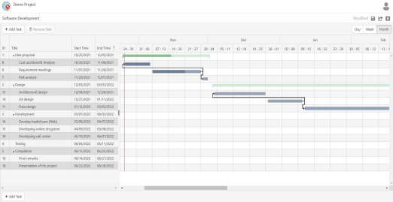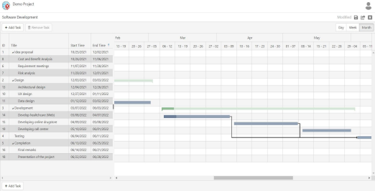Gantt Chart for the project

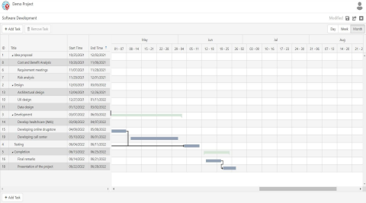

2. Requirements specification (F2)

2.1 Functional Requirements Specification

*In this section, provide the table for functional requirements, including name, source and significance for the project. Each requirement has to be assigned to a specific group, i.e., interface, conversion, database, data exchange.*

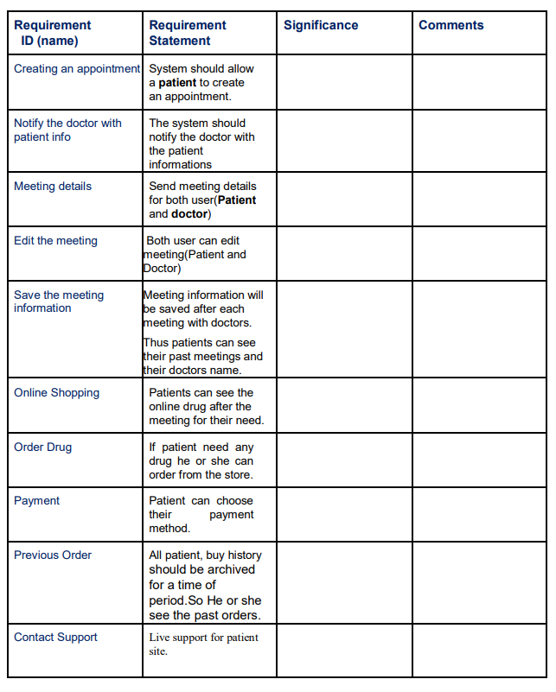

2.2 Non-Functional Requirements

*In this section provide the table for non-functional requirements that includes name, source, significance for the project and the type of requirement, e.g., efficiency, standards, constraints, etc*

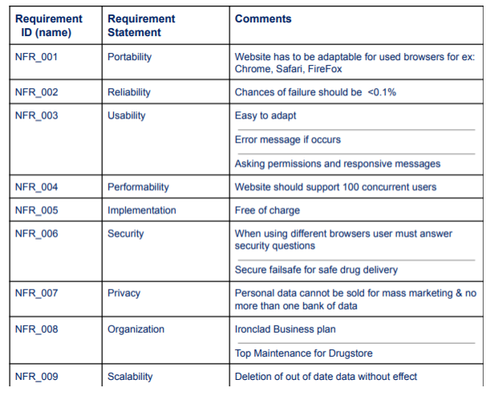

2.3 Requirement Matrix

*The complexity of relationships among requirements and stakeholders should be depicted in the form of significance matrix. The dimensions are respectively, a set of requirements and a set of stakeholders. At the intersection of the dimensions, we place the level of significance (0-5) of the specific requirement for a particular stakeholder*.

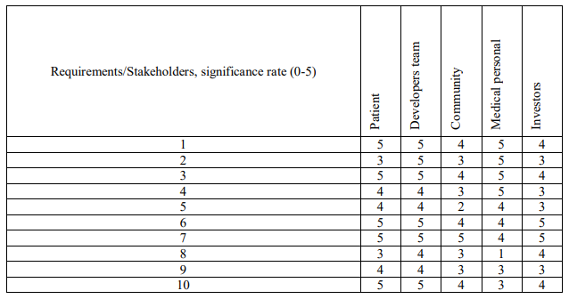

2.4 Requirements Diagram

*You should prepare the diagram in SysML 1.5 presenting the requirements model, including both functional and non-functional requirements. It is defining the elements fulfilled by the requirement (satisfy), elements accepting the requirement (verify), elements specifying the requirements (refine) and elements that track requirements (trace).*

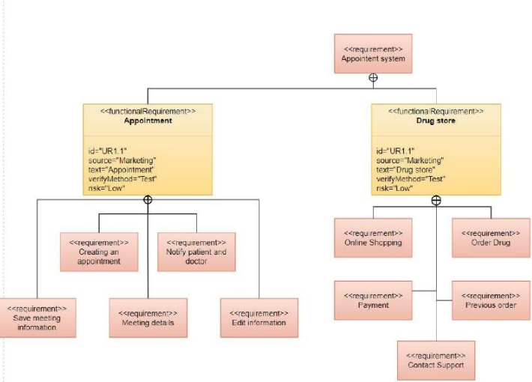

2.5 Use Case Diagram

*You should prepare the use case diagram in UML 2.5 depicting the roles of stakeholders who are users of the project. It should also present the high-level concept of system usage divided into modules. Please describe the critical use cases in the natural language or with the use of behavioural diagrams.*

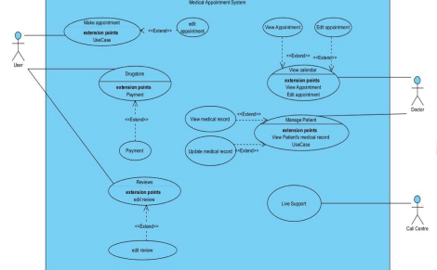

2.6 Dictionary and Business Rules

*In this section, you should include the dictionary of business concepts present in the project. You can also define rules in a natural language or with the use of a formalised standard dedicated to business rules in SBVR*.

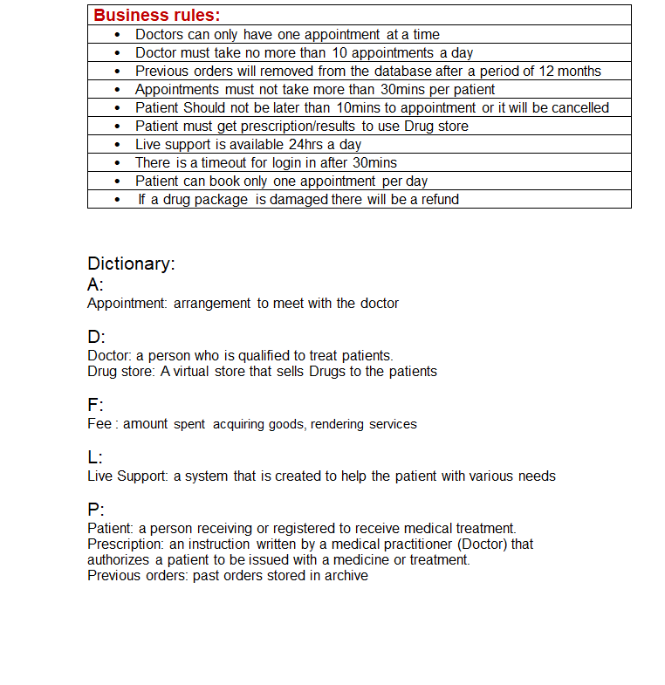

3.1 Logical Data Model

3.1.1 Structural Model

*Prepare the model as class and component diagrams expressed in UML 2.5. Use natural language to describe the semantics of models’ elements. Besides, use the object diagram to present an instance of the model at the time of system execution.*

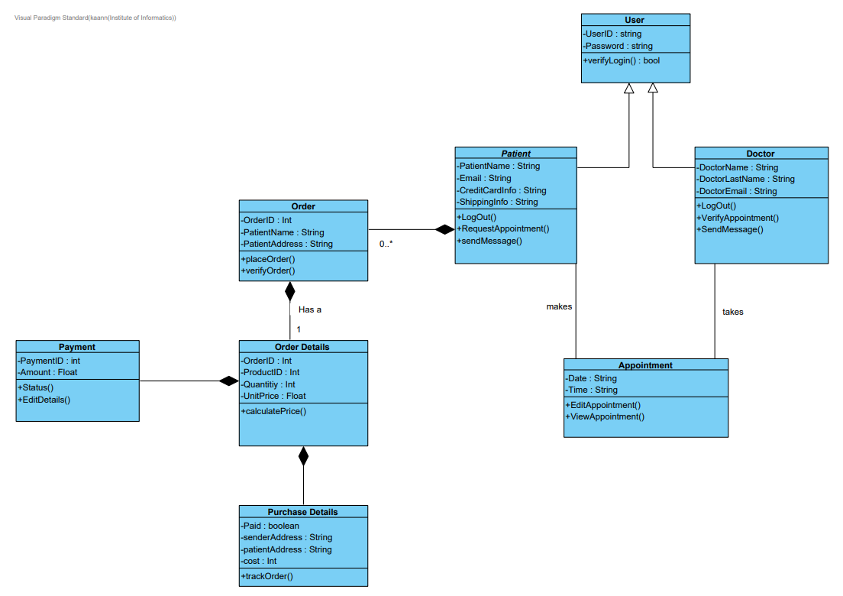

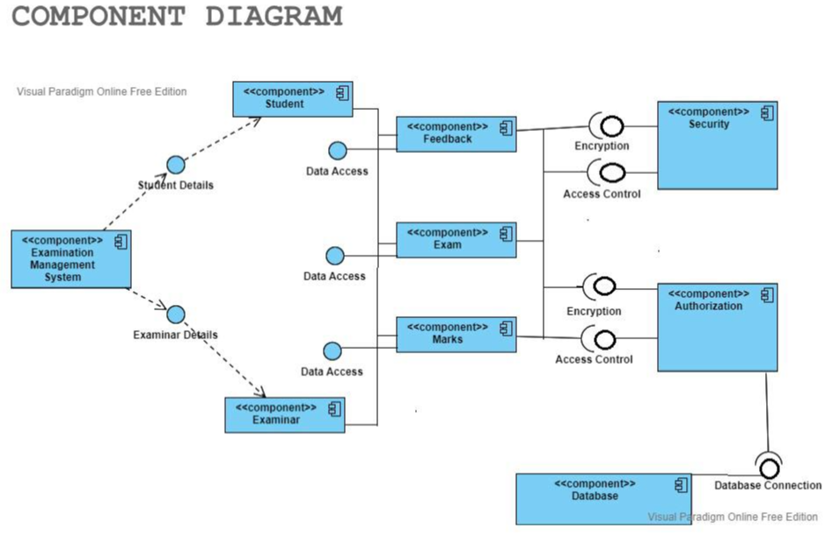

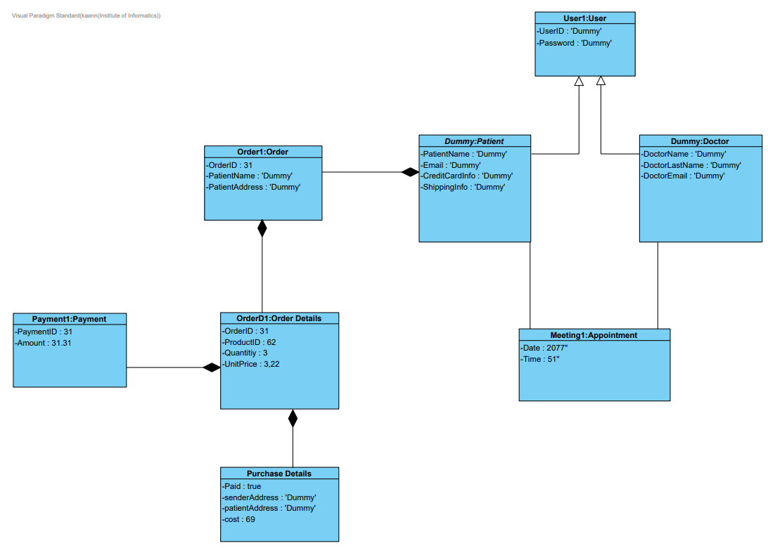

3.1.2 Behavioural Model

*In this section present behaviour of crucial use cases using the UML 2.5 diagrams, namely sequence diagram, state diagram, and activity diagram.*

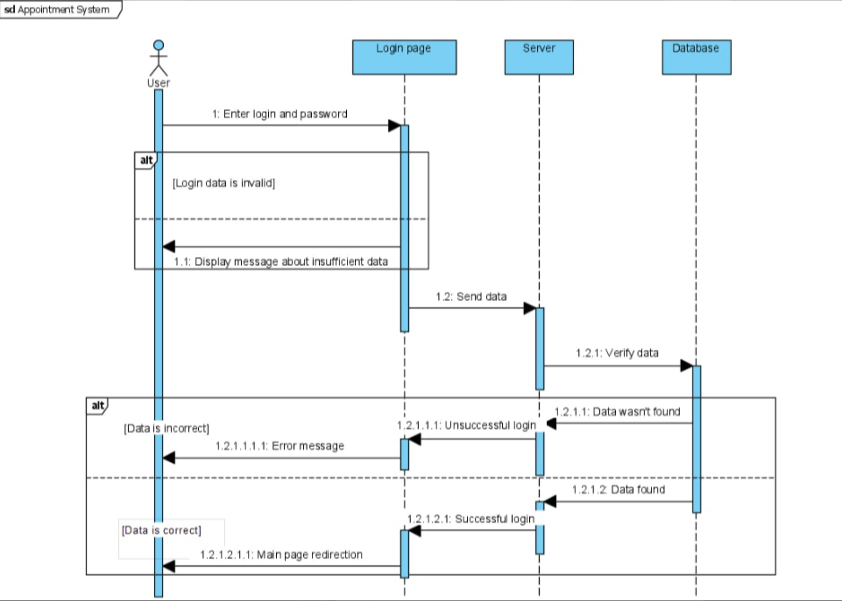

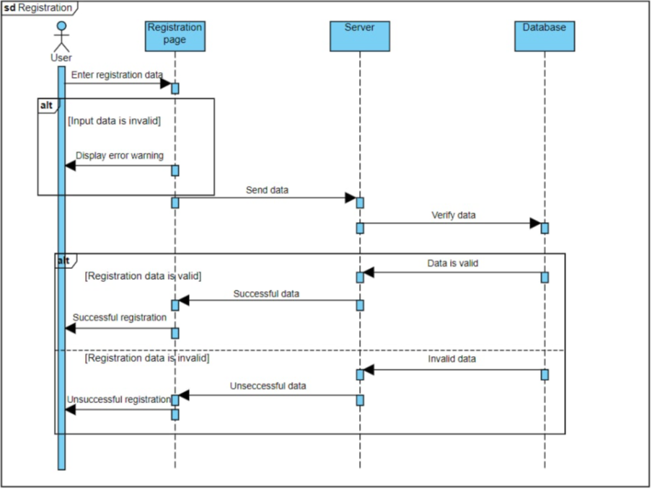

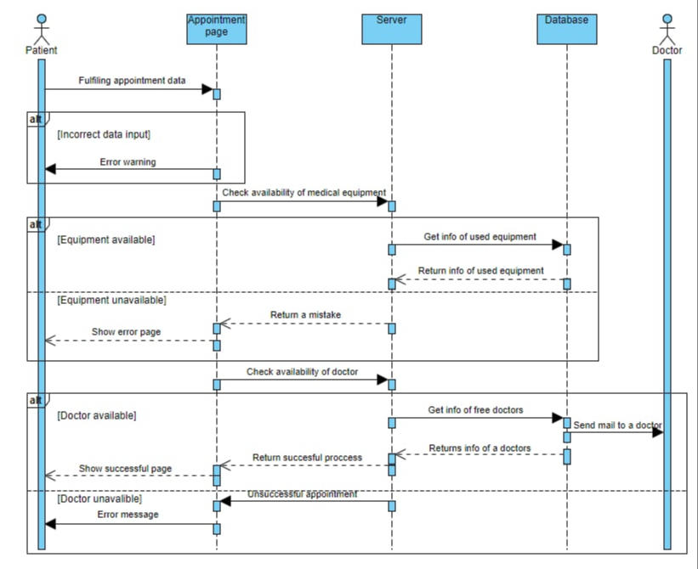

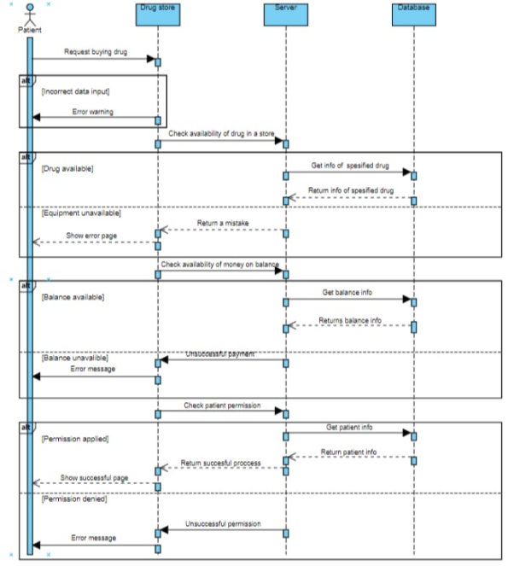

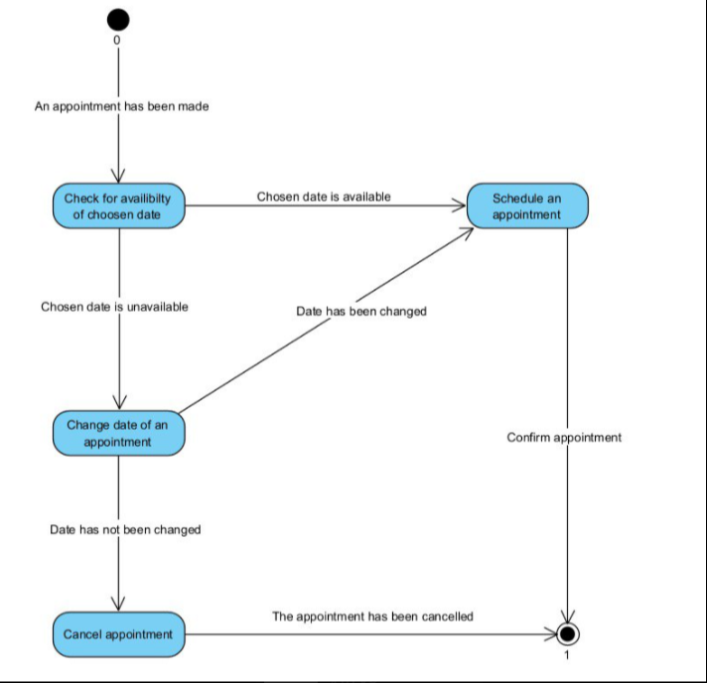

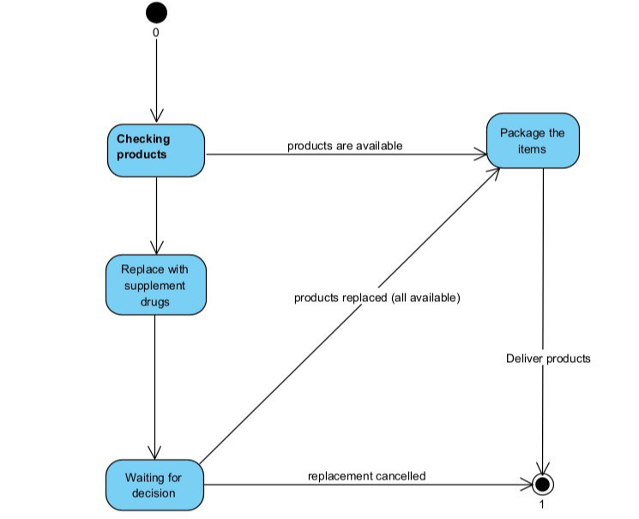

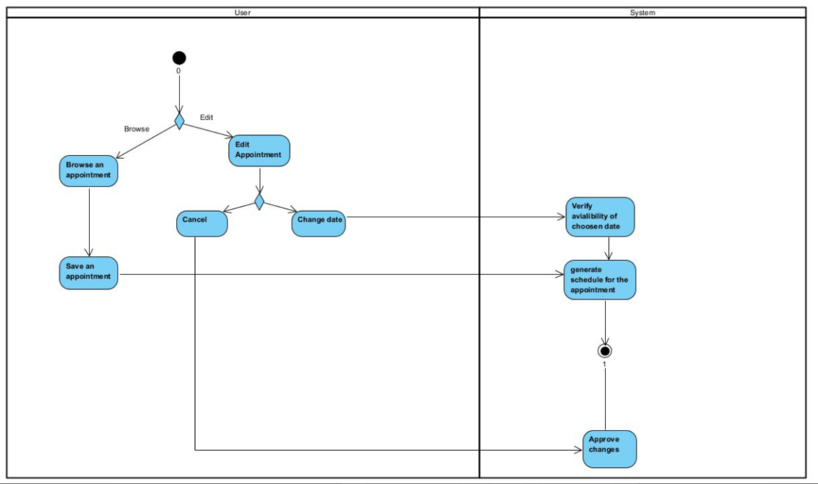

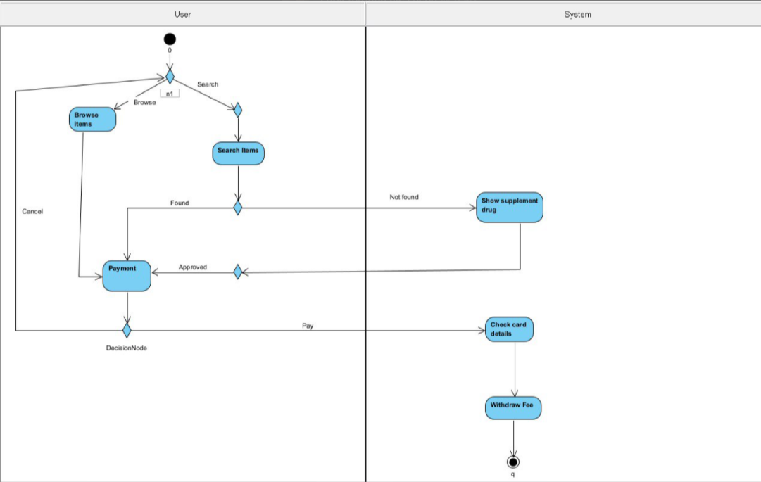

3.2 Database Model

3.2.1 Conceptual Model

*The model contains the definition of entities and relationships among them in terms of the database (persistence). You should present it as a diagram and description of key elements in natural language.*

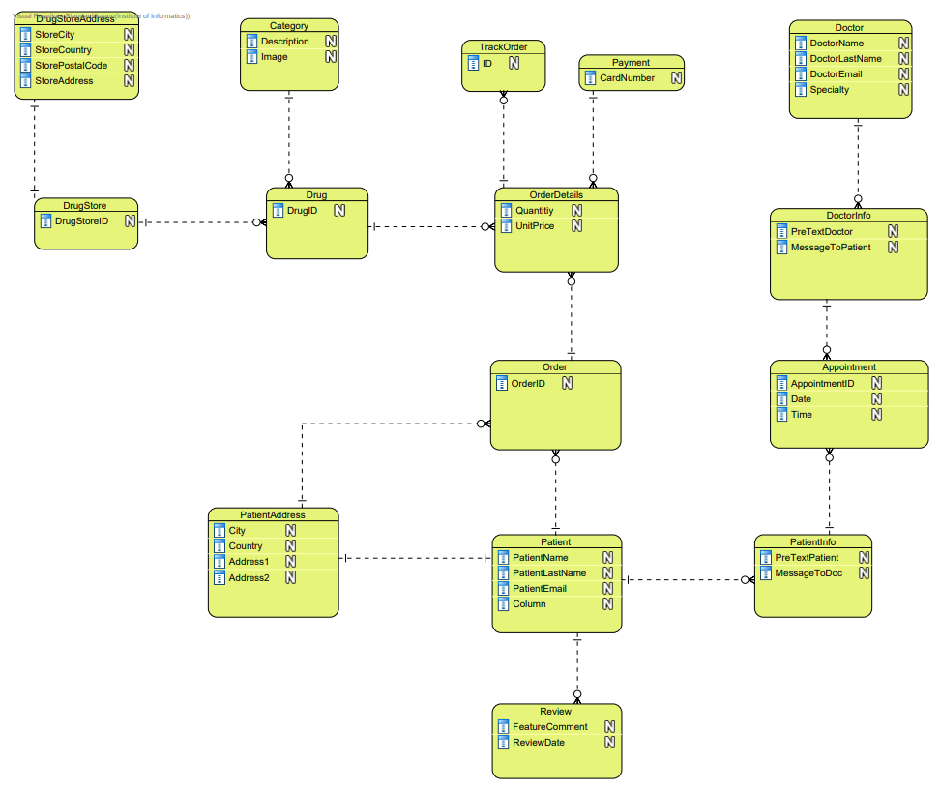

3.2.2 Physical Model

*The model presented as a diagram of the database that constitutes the implementation of the conceptual model in the selected database management system.*

*It is required to include an elaboration on transformations used in the process.*

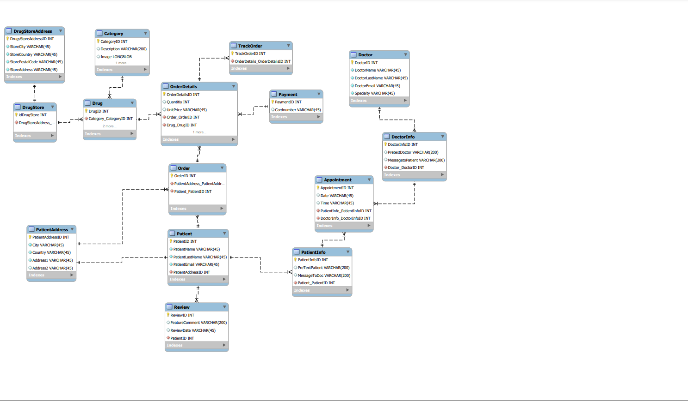

3.3 Software Architecture

*The architecture aspect of the system should be present as a Deployment Diagram expressed in UML 2.5. It shows the placement of prepared and implemented software and hardware artefacts on specific devices.*

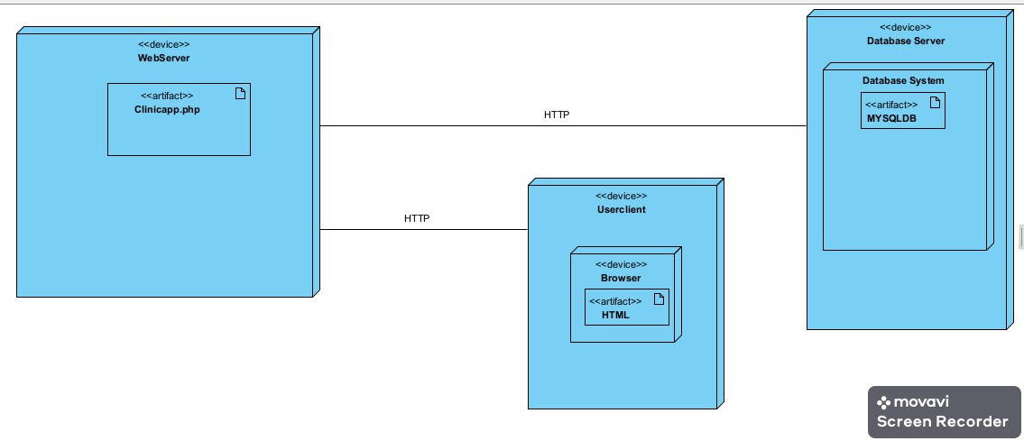

3.4 User Interface Design

*In this section, you should present the distribution of user interface elements with their assignments to the behaviour specifications, which these elements initiate or take part in.*

